MONGODB LAB WORK

**Structure of 'restaurants' collection:**

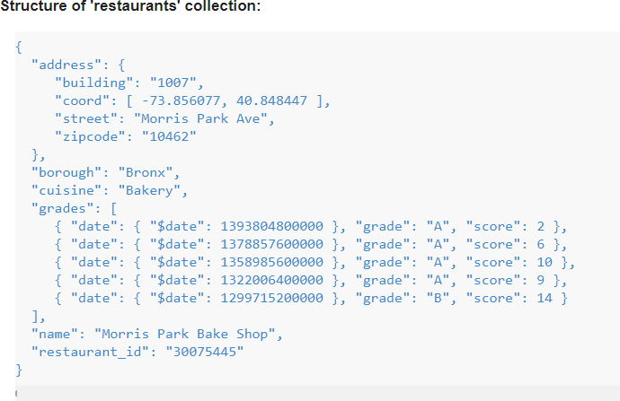

1. Write a MongoDB query to display all the documents in the collection restaurants.

- db.RestaurantDetails.find**()**

1. Write a MongoDB query to display the fields restaurant_id, name, borough and cuisine for all the documents in the collection restaurant

-db.RestaurantDetails.find**({},{**"restaurant_id"**:**1**,**"name"**:**1**,**"borough"**:**1**,**"cuisine"**:**1**})**

1. Write a MongoDB query to display the fields restaurant_id, name, borough and cuisine, but exclude the field _id for all the documents in the collection restaurant

-db.RestaurantDetails.find**({},{**_id**:**0**,**"restaurant_id"**:**1**,**"name"**:**1**,**"borough"**:**1**,**"cuisine"**:**1**})**

1. Write a MongoDB query to display the fields restaurant_id, name, borough and zip code, but exclude the field _id for all the documents in the collection restaurant

-db.RestaurantDetails.find**({},{**_id**:**0**,**"restaurant_id"**:**1**,**"name"**:**1**,**"borough"**:**1**,** "address"**:{**"zipcode"**:**1**}})**

1. Write a MongoDB query to display all the restaurant which is in the borough Bronx.

-db.RestaurantDetails.find**({**

"borough"**:**"Bronx"

**})**

1. Write a MongoDB query to display the first 5 restaurant which is in the borough Bronx

-db.RestaurantDetails.find**({**"borough"**:**"Bronx"**})**.limit**(**5**)**

1. Write a MongoDB query to display the next 5 restaurants after skipping first 5 which are in the borough Bronx

-db.RestaurantDetails.find**({**"borough"**:**"Bronx"**})**.skip**(**5**)**

1. Write a MongoDB query to find the restaurants who achieved a score more than 90

-db.RestaurantDetails.find**({**"grades"**:{**"score"**:{**$gt**:**90**}}})**

1. Write a MongoDB query to find the restaurants that achieved a score, more than 80 but less than 100

-db.RestaurantDetails.find**({**"grades"**:{**"score"**:{**$gt**:**80**,**$lt**:**100**}}})**

1. 10. Write a MongoDB query to find the restaurants which locate in latitude value less than -95.754168

db.RestaurantDetails.find**({**"address"**:{**"coord"**:{**$lt**:**-95.754168**}})**

1. Write a MongoDB query to find the restaurants that do not prepare any cuisine of 'American' and their grade score more than 70 and latitude less than -65.754168.

- db.RestaurantDetails.find**({**$and**:[{**"cuisine"**:{**$ne**:**"American"**}},{**"grades"**:{**"score"**:{**$gt**:**70**}}},{**"address"**:{**"coord"**:{**$lt**:**-65.754168**}}}]})**

1. Write a MongoDB query to find the restaurants which do not prepare any cuisine of 'American' and achieved a score more than 70 and located in the longitude less than -65.754168.

Note : Do this query without using $and operator.

- db.RestaurantDetails.find**({**"cuisine"**:{**$ne**:**"American"**}},{**"grades"**:{**"score"**:{**$gt**:**70**}}},{**"address"**:{**"coord"**:{**$lt**:**-65.754168**}}})**

1. Write a MongoDB query to find the restaurants which do not prepare any cuisine of 'American ' and achieved a grade point 'A' not belongs to the borough Brooklyn. The document must be displayed according to the cuisine in descending order.

-db.RestaurantDetails.find**({**$and**:[{**"cuisine"**:{**$ne**:**"American"**}},{**"grades"**:{**"grade"**:**"A"**}},{**"borough"**:{**$ne**:**"Brooklyn"**}}]})**.sort**({**"cuisine"**:**-1**})**

1. Write a MongoDB query to find the restaurant Id, name, borough and cuisine for those restaurants which contain 'Wil' as first three letters for its name.

-db.RestaurantDetails.find**(**

**{**"name"**:** /^Wil/**},**

**{**

"restaurant_id" **:** 1**,**

"name"**:**1**,**"borough"**:**1**,**

"cuisine" **:**1

**}**

**);**

1. Write a MongoDB query to find the restaurant Id, name, borough and cuisine for those restaurants which contain 'ces' as last three letters for its name.

-db.restaurants.find**(**

**{**"name"**:** /ces$/**},**

**{**

"restaurant_id" **:** 1**,**

"name"**:**1**,**"borough"**:**1**,**

"cuisine" **:**1

**}**

**);**

Live Tasks Day3

1. Show the record where name =”Akash”

Solu - db.Registration.find({"name":"Akash"})

1. Show the record where location =”Mumbai”

Solu -db.Profile.find({"Location":"Mumbai"})

1. Display people whose fees is less than 50000.

Solu - db.Registration.find({"fees" :{$lt:50000}})

1. Display the document where fees <20000 and course is java

Solu -db.Registration.find({$and:[{"fees":{$lt:20000}},{"course":"java"}]})

1. Display the document where fees between 20000 and 50000 and course is java

Solu -db.Registration.find({$and:[{"fees":{$gte:20000,$lte:50000}},{"course":"java"}]})